**JumboSpot DMR Hotspot**

Saturday, February 10, 2018 by

One of the latest crazes in the world of DMR radio is the Chinese iteration of the DMR hotspot. The principal attraction? Low cost. The Jumbospot costs about $45 and I've heard tales of people getting them for $35. Slap it on top of a Raspberry Pi Zero W which costs $10 and an SD card and you are on the air for about $70 or so if you factor in everything. Add a $9 OLED display and you still haven't broken the bank yet.

So JumboSpot is cheap and **like it or not** this is the way that a lot of people are going to go. So I ordered one.

To tell you the truth I didn't expect much, heck I even expected that it might not work but I was up and running in 20 minutes and much of that time was spent soldering the firmware header pins on and the antenna connector. I had read several horror stories on the internet regarding Jumbospot (which many call "ChinaSpot") and they are downright scary. Then after working through it myself it is fairly apparent that the problem here is the Linux and Raspberry Pi aspect of it. Many people just don't know or understand Linux, Linux networking, etc. And it is a bit daunting if you have never been exposed to it before. And plan on doing a little soldering. They don't even come with the antenna connector on them. At least mine didn't.

Also it seems to me that there are Jumbospots on eBay that have subtle differences. You might be best served to buy one from Aliexpress.com where at least you can send it back if it doesn't work. I bought mine from eBay and paid $45 for it. So let’s take it out of the anti-static bag and lets prepare the hardware. Bust out the soldering iron.

**NOTE: If you intend to solder an OLED display to the JumboSpot beware that some OLED pin arrangements are GND, VCC, SCL, SDA. The OLED's that I have here have this arrangement. Be sure your Vcc (Voltage) and GND are not reversed before you install and solder.**

Also mine came with no ceramic antenna soldered on the board. This is good because most folks are removing them anyway.

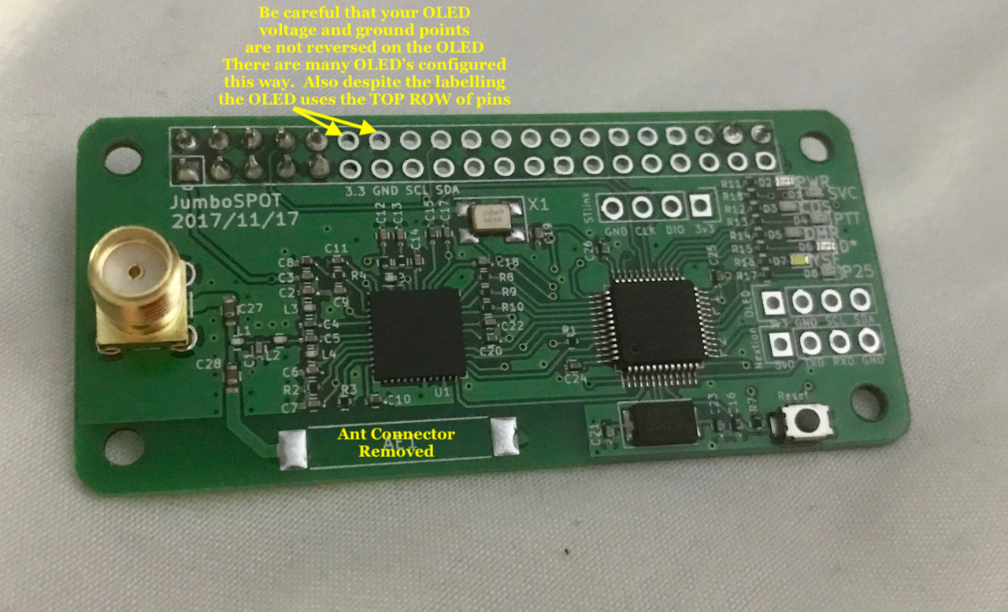

Solder a 2 pin header to Pins 38 and 40 of the Pi. Your Jumbospot will work fine without these two pins but you will NOT be able upgrade the board firmware without it. I don't want to get too technical here but pins 38 and 40 are the corresponding Pi GPIO 20, and 21 pins. Here's one of the lines from the script file that update the firmware.

(sudo stm32flash -v -w 7021\_HShat.ino.bin -g 0x0 -R -i 20,-21,21:-20,21 /dev/ttyAMA0)

You might notice there a lot of 20, and 21's in that command. That's where the action happens folks. No 2 pin header.........no firmware write.

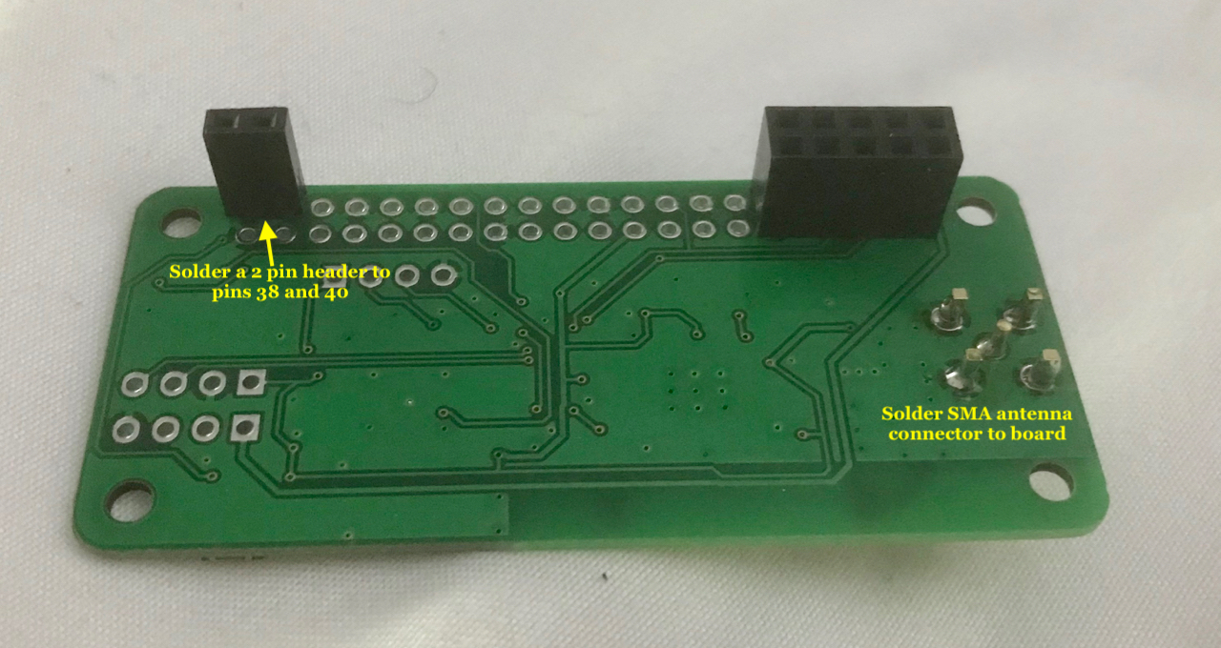

Okay.......We have a 2 pin header on pins 38 and 40 and our SMA connector is soldered to the board. Lets prepare the software. We're going to use Pi-Star OS which is basically Debian Linux or Raspbian Raspberry Pi OS. Go to the [Pi-Star download website](http://www.pistar.uk/downloads/) It will download a zip file. Here's one of the big problems with burning the image.

UNZIP THE FREAKING FILE! Inside the zip file is a file with a dot img extension (.img). That is what goes on the SD Card. Make sure to Download the RPi file (if you are using a Raspberry Pi. If you have no clue how to burn the image look down the page and there are guides for WIndows, Mac, and Linux.

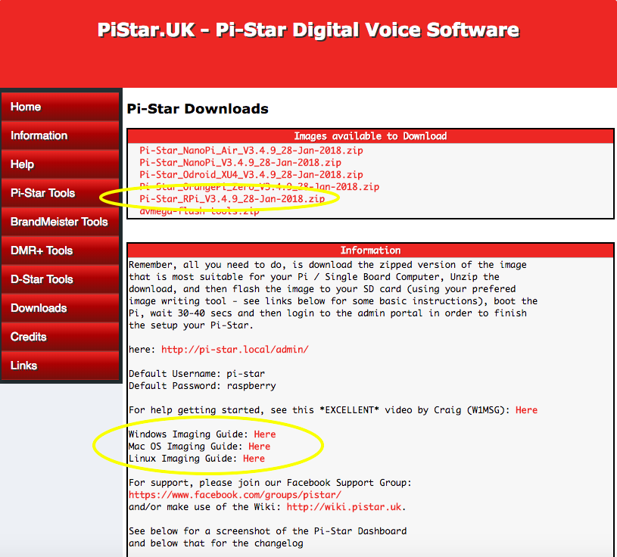

I'm going to make it easy for you. I have a Mac and the command is called "dd" . That is the old Unix/Linux command called "Disk Destroyer" so since many folks reading this page will undoubtedly be angry if they follow this guide and wipe their hard drive on their computer I'm not going there here. I'm serious. If you put the wrong device number down for your device you'll wipe and re-write your hard drive, back up drive, whatever.

Sooooo.........download a program called [Etcher](https://etcher.io/) Point it to your Pi-Star Download image file. FOR GOD'S SAKE UNZIP THE FREAKING FILE. DON'T BURN THE ZIP FILE. DID YOU HEAR ME?

Then select your SD card reader and hit the flash button. Takes 5 minutes or so. And then you are DONE.

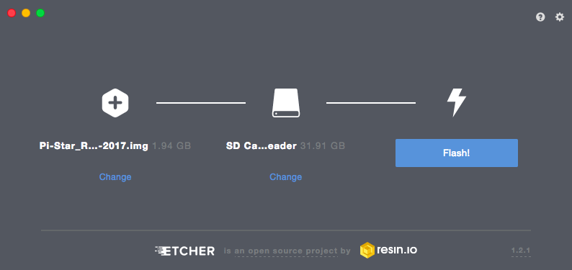

Now..............before you remove that card go back to the Pi-Star website and go to the [WiFi Builder page](http://www.pistar.uk/wifi_builder.php" \t "_blank) Insert your credentials and hit the "submit" button.

LEAVE THE SD CARD IN .........find it in the file manager and stand by to add a file to it.

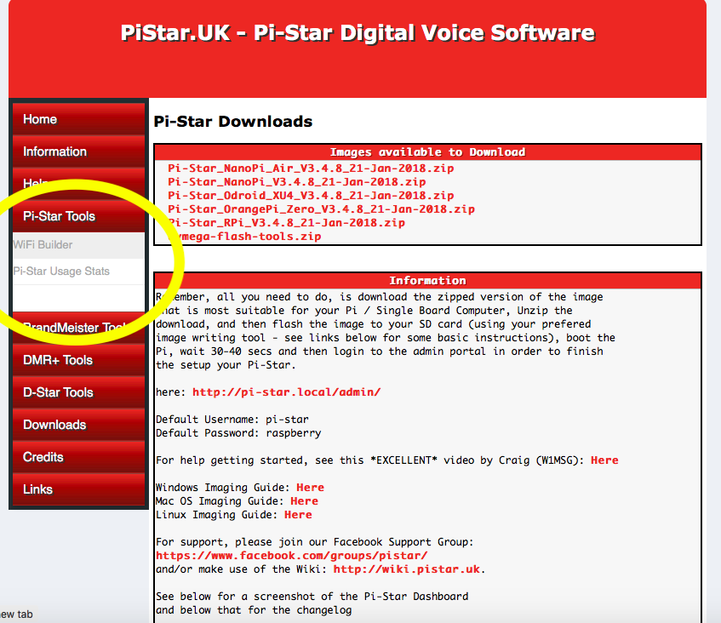

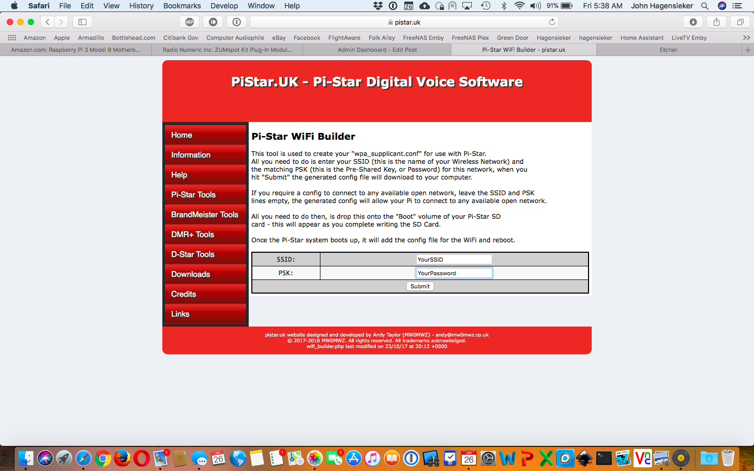

Once you hit submit it will download a file called

wpa\_supplicant.conf

SIMPLY DRAG AND DROP THAT wpa\_supplicant.conf FILE TO YOUR SD CARD. At the first boot up your JumboSpot / RPi combo will connect to your wifi. I hope you know by now the Pi Zero W has to have a 40 pin male header soldered to it as well.

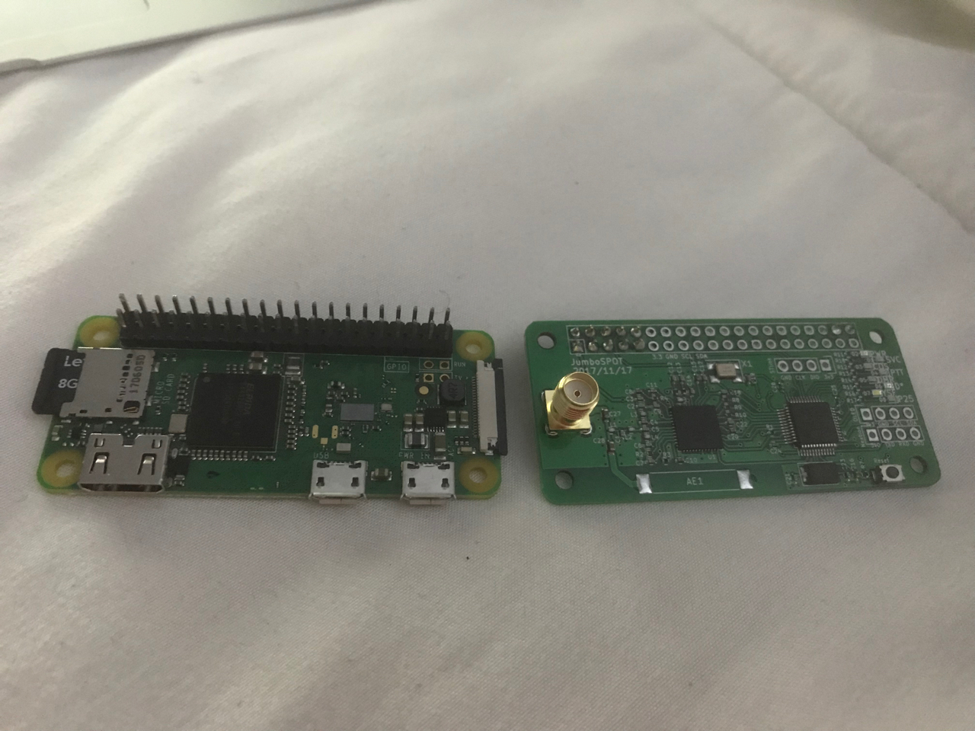

Install the JumboSpot on the Pi

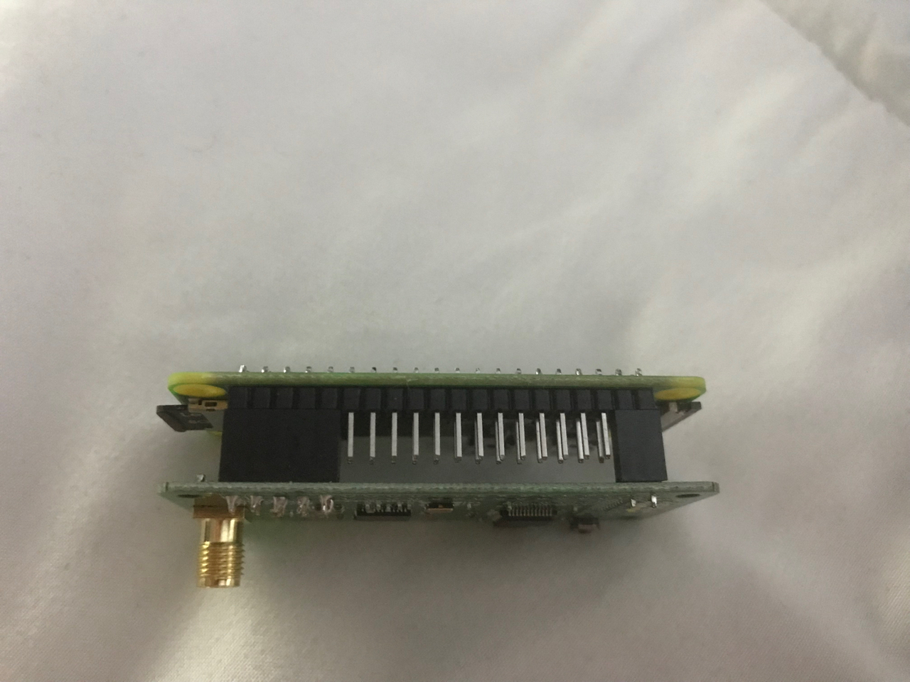

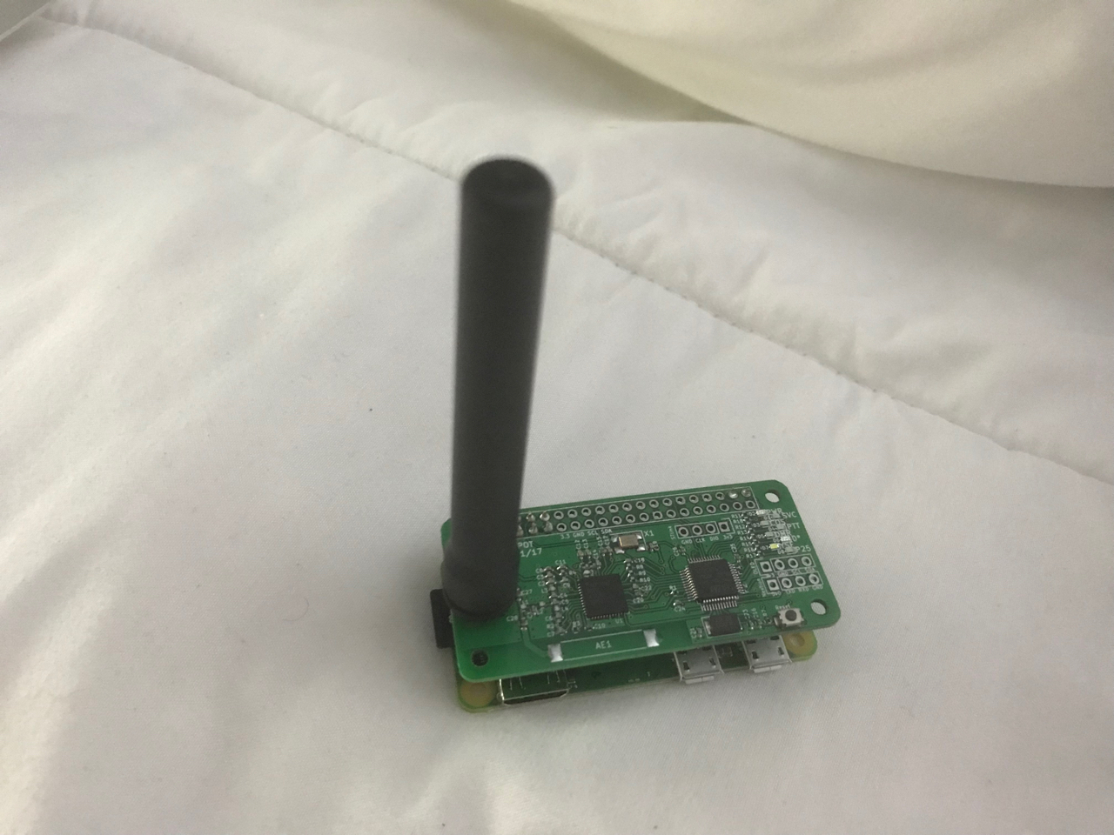

Now you can get on the SAME wifi network with a computer, open a browser and scroll to pi-star.local/

Be sure to include the dash. If for some reason THIS DOES NOT WORK, clear the cache in your browser and try again, especially if you've had other pi-star devices connected before. If that doesn't work open a terminal (in Mac it is called terminal, in Windows it is called CMD for command prompt) Then type

ping pi-star.local (this time WITHOUT the trailing dash)

You'll notice that it answers WITH THE IP ADDRESS. So in this case just point your browser to 192.168.20.69 (your IP address is going to be different).

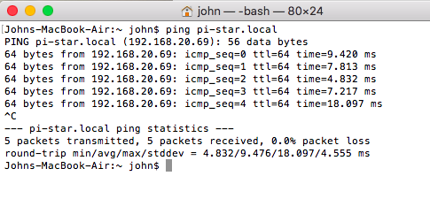

At this point you need to configure Pi-Star. I'm not going to go too deep here. Initially you will be asked for a password. The default user name and password is:

user = pi-star

pass = raspberry

I'm not going too deep here but to configure Pi-Star for DMR essentially just add the following at the configuration page:

Select MMDVMHost

Simplex Mode

DMR Mode

If you have an OLED soldered on add it here by using the drop down box

Your host name can be anything. Just leave it at pi-star

Add your Callsign

Add DMR ID (initially this will not be on the first configuration page. It will have you reset the modem then you can add it)

Add your Simplex Frequency

Lat/Long/Altitude is optional but nice to add.

Hit auto for URL and it will add your callsign

Use the Radio/Modem type I have selected

Set Time Zone

Set your BrandMeister server. I use 3102 most of the time.

Color Code is 1

**BE SURE TO HIT APPLY CHANGES BUTTON SOMEWHERE ON THE PAGE WHEN FINISHED. IF YOU NAVIGATE AWAY FROM THIS PAGE YOUR CHANGES WILL NOT BE SAVED.**

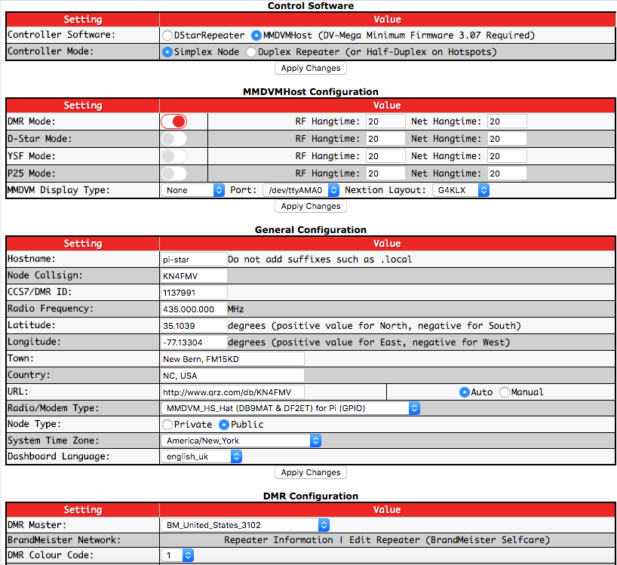

OK! Congrats! You should be talking to people by now. Now lets upgrade that firmware. This is tricky stuff.

Navigate to Expert mode in the browser using this address:

<http://pi-star.local/admin/expert/>

Then select SSH Access and login using your credentials. (pi-star, raspberry)

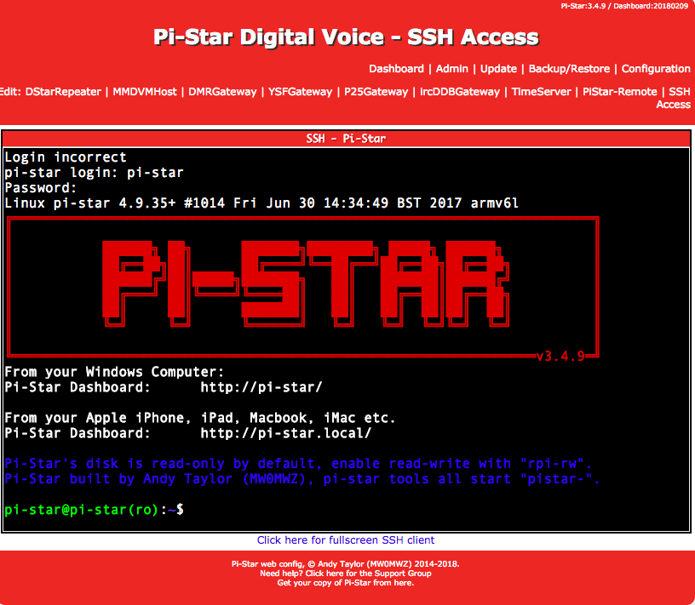

Once logged in follow the directions on the screen and type in this command

rpi-rw

That lets you in write mode so you can update the firmware.

Now issue these commands to upgrade the firmware:

cd /usr/bin

sudo wget [http://vk4tux.duckdns.org/izspot/hsfw.sh](https://l.facebook.com/l.php?u=http%3A%2F%2Fvk4tux.duckdns.org%2Fizspot%2Fhsfw.sh&h=ATOv_NId95gnWXdLjNo_VV-6tJg-YUhxZfjXB4tZjxLevTT21Vezy5DtlfmFOv6qdoA_sdfDzmrBC4e2yuB2Lbf9jQYJT5cK5jEmGhUcNwZ1ZUxbkYS-OiwZoG09HXTYBAT4RWh6nGOizkCu2MgE)

sudo chmod 755 hsfw.sh

sudo hsfw.sh

after the last command it will write the firmware and re-boot the JumboSpot/Rpi. Here's something not mentioned. Once you download that firmware file (hsfw.sh) the next time you go to download a firmware upgrade Linux will probably name it hsfw(1).sh or something like that. I'm not positive but that's probably what will happen. At any rate you do not need the file after the firmware is flashed so for general housekeeping and tidiness (not Tide Pods) let's get rid of it. Again log into SSH ACCESS first.

rpi-rw

cd /usr/bin

sudo rm -r hsfw.sh

You are good to go and running the latest firmware. And be sure and call for KN4FMV on TG 3100 USA if this helped you at all!.

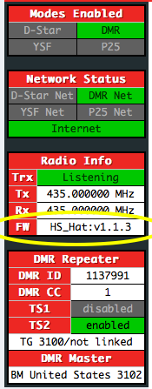

**\*\*\*\*\*\*\*\*\*\*\*\*\*\*\*\*\*\*\*\*\*\*\*\*\*\*\*\*\*UPDATE 12 FEB 2018\*\*\*\*\*\*\*\*\*\*\*\*\*\*\*\*\*\*\*\*\*\*\*\*\*\*\*\*\***

Finally received the proper OLED and soldered it in. Works as advertised.

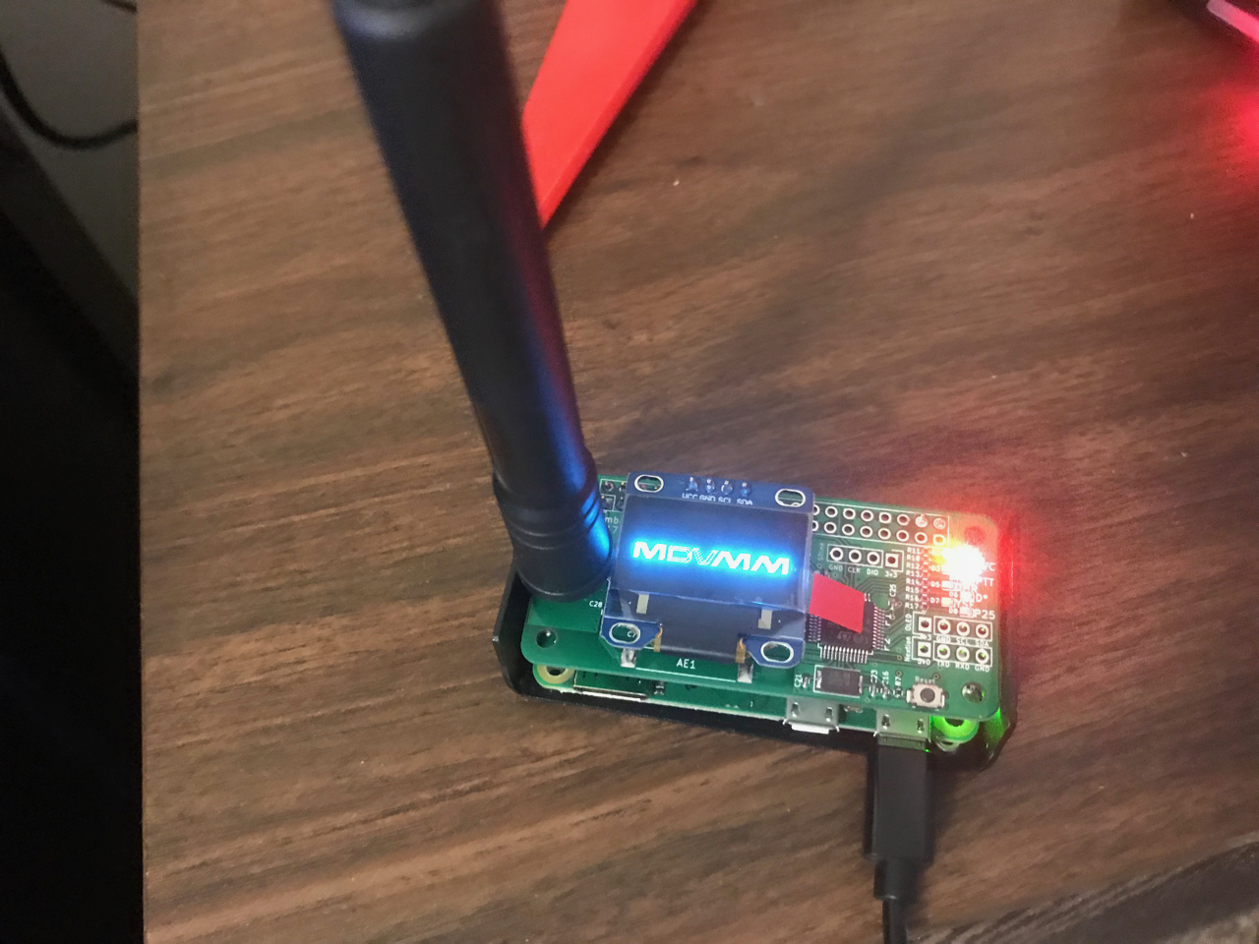

Also got one of the aluminum cases that they sell on eBay. Looks nice and professional.

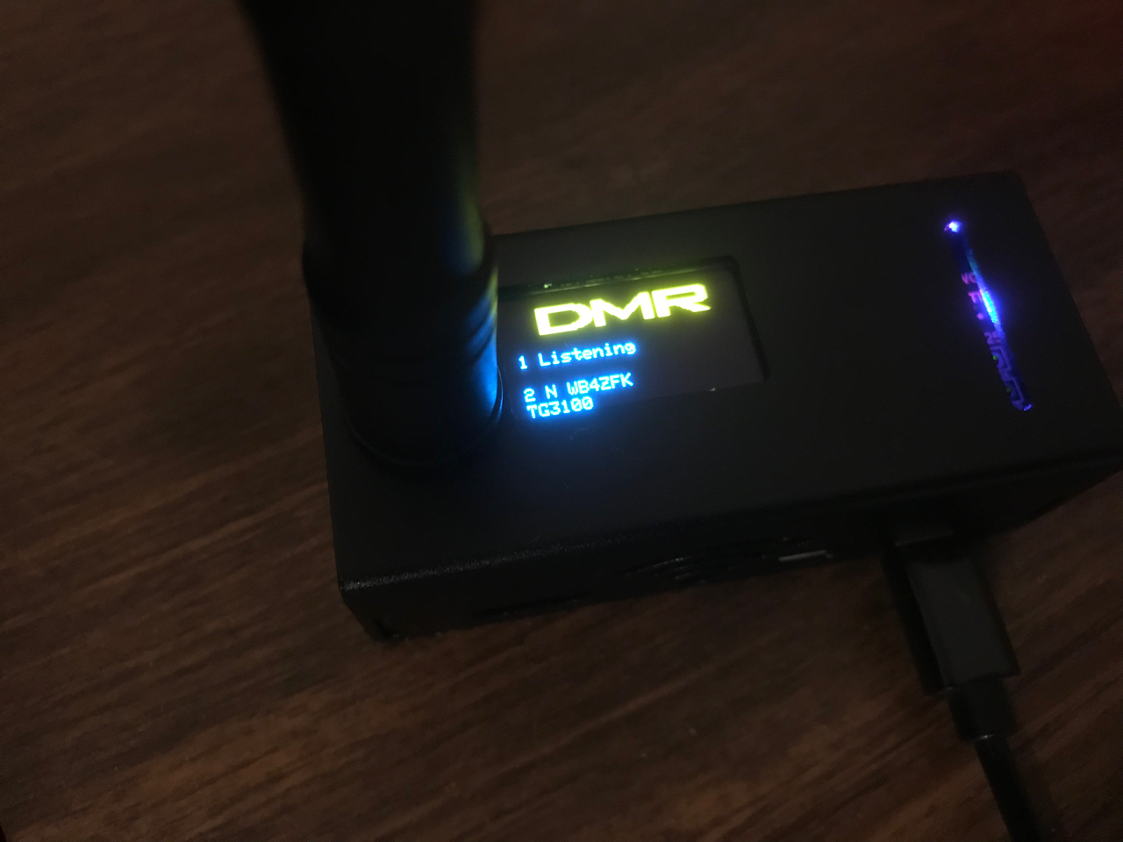

You can say or think anything you want about the JumboSpot but this simple fact remains. They cost $45. Because of the price of competing hotspots people are going to buy these. They work. The OLED and case are cheap and look GOOD.